## 实验三 编码器和译码器

22920182204307 王泽宇

1. 实验目的

1.掌握编码器和译码器的基本设计方法

2. 掌握集成译码器的功能

1. 实验设备和器材

数字逻辑试验箱 1台

4输入二与非门 （7420） 2片

2输入四或门 （7432） 1片

2输入四与非门 （7400） 1片

1. 四译码器 （74LS139） 1片
2. 八译码器 （74LS138） 1片
3. 实验内容
4. 二-八进制编码器设计

8个输入端代表0~7这8个数字（用8个逻辑开关来表示）； 3个输出端代表对应的3位二进制代码。其真值表如表3.1所示。由真值表可知不允许两个或两个以上数字同时输入，则除真值表中的9种输入组合外，其余组合均为无效组合。要求由真值表直接写出输出函数，画出电路图。

|  |  |  |  |  |  |  |  |  |  |  |  |  |
| --- | --- | --- | --- | --- | --- | --- | --- | --- | --- | --- | --- | --- |
| 十进制数 | 输入 | | | | | | | | 输出 | | |  |
| D7 | D6 | D5 | D4 | D3 | D2 | D1 | D0 | A | B | C | S |
|  | 0 | 0 | 0 | 0 | 0 | 0 | 0 | 0 | 0 | 0 | 0 | 0 |
| 0 | 0 | 0 | 0 | 0 | 0 | 0 | 0 | 1 | 0 | 0 | 0 | 1 |
| 1 | 0 | 0 | 0 | 0 | 0 | 0 | 1 | 0 | 0 | 0 | 1 | 1 |
| 2 | 0 | 0 | 0 | 0 | 0 | 1 | 0 | 0 | 0 | 1 | 0 | 1 |
| 3 | 0 | 0 | 0 | 0 | 1 | 0 | 0 | 0 | 0 | 1 | 1 | 1 |
| 4 | 0 | 0 | 0 | 1 | 0 | 0 | 0 | 0 | 1 | 0 | 0 | 1 |
| 5 | 0 | 0 | 1 | 0 | 0 | 0 | 0 | 0 | 1 | 0 | 1 | 1 |
| 6 | 0 | 1 | 0 | 0 | 0 | 0 | 0 | 0 | 1 | 1 | 0 | 1 |
| 7 | 1 | 0 | 0 | 0 | 0 | 0 | 0 | 0 | 1 | 1 | 1 | 1 |

表3.1

1. 用门电路实现二-四译码器，其真值表如表 3.2 所示。要求由真值表求出输出函数，画出电路图。

|  |  |  |  |  |  |
| --- | --- | --- | --- | --- | --- |
| 输入 | | 输出 | | | |
| A | B | Y0 | Y1 | Y2 | Y3 |
| 0 | 0 | 0 | 1 | 1 | 1 |
| 0 | 1 | 1 | 0 | 1 | 1 |
| 1 | 0 | 1 | 1 | 0 | 1 |
| 1 | 1 | 1 | 1 | 1 | 0 |

表3.2

1. 集成译码器 74139 和 74138 的功能测试。

四、实验步骤

1. 完成二-八进制编码器和二-四译码器的逻辑设计，注意可提供的器件为四输入二与非门（74LS20）、二输入四或门（74LS32）和二输入四与非门（74LS00）。

(1)二-八进制编码器

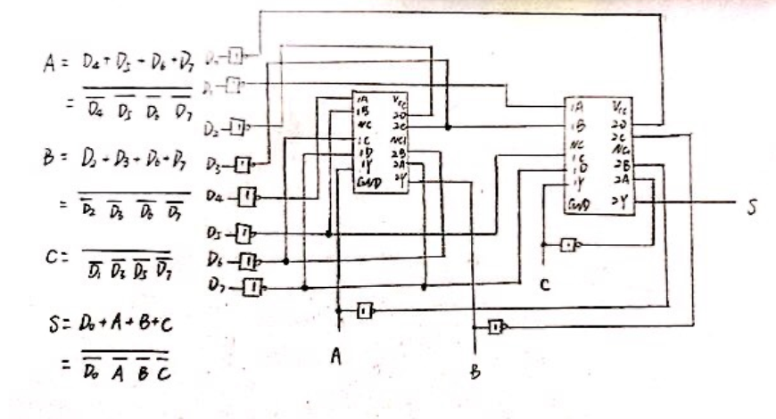

(2)二-四译码器

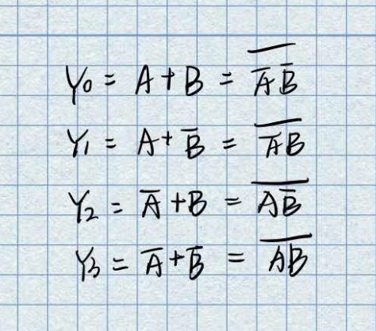

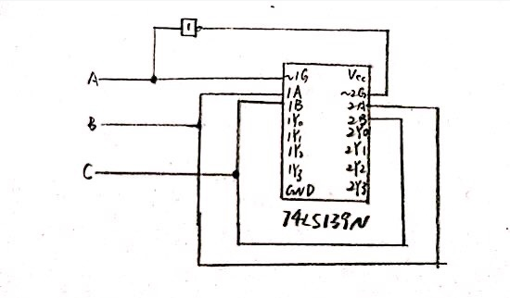

2. 画出电路图，并标上引脚标号。

(1)二-八进制编码器

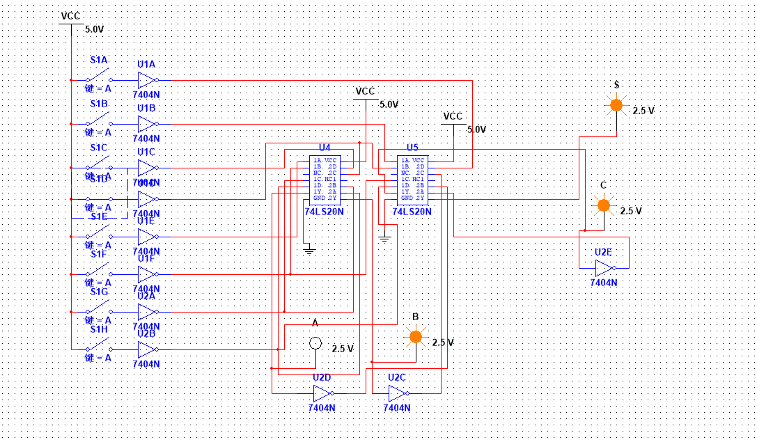

(2)二-四译码器

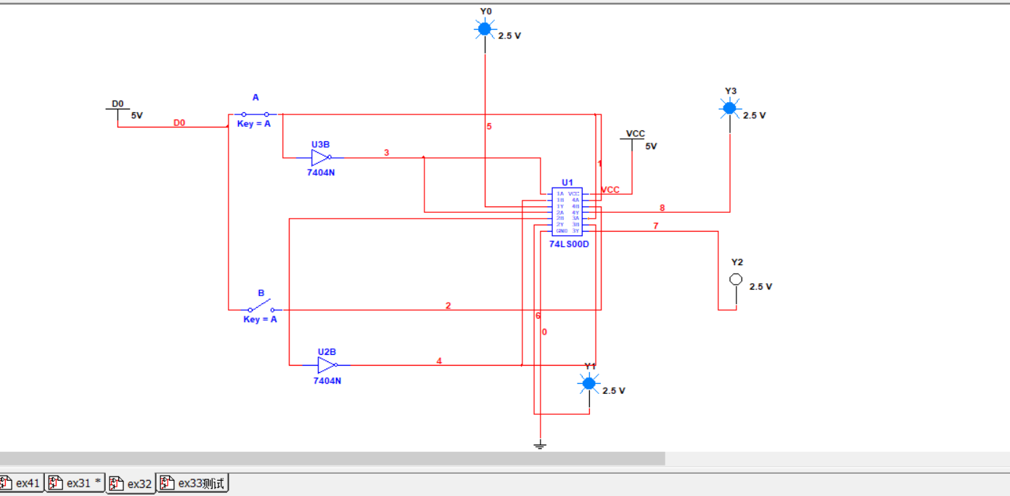

3．连接二—八进制编码器电路，输入逻辑电平用开关提供，输出结果用 LED 来显示。在检查电路连接正确后，接通电源，进行实验，根据实验结果填写真值表，并和原真值表进行比较，检查实验结果是否正确。

|  |  |  |  |  |  |  |  |  |  |  |  |  |
| --- | --- | --- | --- | --- | --- | --- | --- | --- | --- | --- | --- | --- |
| 十进制数 | 输入 | | | | | | | | 输出 | | |  |
| D7 | D6 | D5 | D4 | D3 | D2 | D1 | D0 | A | B | C | S |
|  | 0 | 0 | 0 | 0 | 0 | 0 | 0 | 0 | 0 | 0 | 0 | 0 |
| 0 | 0 | 0 | 0 | 0 | 0 | 0 | 0 | 1 | 0 | 0 | 0 | 1 |
| 1 | 0 | 0 | 0 | 0 | 0 | 0 | 1 | 0 | 0 | 0 | 1 | 1 |
| 2 | 0 | 0 | 0 | 0 | 0 | 1 | 0 | 0 | 0 | 1 | 0 | 1 |
| 3 | 0 | 0 | 0 | 0 | 1 | 0 | 0 | 0 | 0 | 1 | 1 | 1 |
| 4 | 0 | 0 | 0 | 1 | 0 | 0 | 0 | 0 | 1 | 0 | 0 | 1 |
| 5 | 0 | 0 | 1 | 0 | 0 | 0 | 0 | 0 | 1 | 0 | 1 | 1 |
| 6 | 0 | 1 | 0 | 0 | 0 | 0 | 0 | 0 | 1 | 1 | 0 | 1 |
| 7 | 1 | 0 | 0 | 0 | 0 | 0 | 0 | 0 | 1 | 1 | 1 | 1 |

4．连接译码器电路，输入逻辑电平用开关提供，输出结果用 LED 来显示。在检查电路连接正确后，接通电源，进行实验，根据实验结果填写真值表，并和原真值表进行比较，检查实验结果是否正确。

|  |  |  |  |  |  |
| --- | --- | --- | --- | --- | --- |
| 输入 | | 输出 | | | |
| A | B | Y0 | Y1 | Y2 | Y3 |
| 0 | 0 | 0 | 1 | 1 | 1 |
| 0 | 1 | 1 | 0 | 1 | 1 |
| 1 | 0 | 1 | 1 | 0 | 1 |
| 1 | 1 | 1 | 1 | 1 | 0 |

5．进行 74LS139 和 74LS138 功能测试。根据实验结果填写真值表，并检查实验数据是否正确。

|  |  |  |  |  |  |  |  |  |  |  |  |  |  |  |  |  |
| --- | --- | --- | --- | --- | --- | --- | --- | --- | --- | --- | --- | --- | --- | --- | --- | --- |
| 74LS138 | | | | | | | | | | | | | | | | |
| 输入 | | | | | | 输出 | | | | | | | | | | |
| S1 | S2+S3 | A2 | A1 | A0 | | $$\overline{Y0}$$ | $$\overline{Y1}$$ | | $$\overline{Y2}$$ | $$\overline{Y3}$$ | | $$\overline{Y4}$$ | $$\overline{Y5}$$ | | $$\overline{Y6}$$ | $$\overline{Y7}$$ |
| 1 | 0 | 0 | 0 | 0 | | 0 | 1 | | 1 | 1 | | 1 | 1 | | 1 | 1 |
| 1 | 0 | 0 | 0 | 1 | | 1 | 0 | | 1 | 1 | | 1 | 1 | | 1 | 1 |
| 1 | 0 | 0 | 1 | 0 | | 1 | 1 | | 0 | 1 | | 1 | 1 | | 1 | 1 |
| 1 | 0 | 0 | 1 | 1 | | 1 | 1 | | 1 | 0 | | 1 | 1 | | 1 | 1 |
| 1 | 0 | 1 | 0 | 0 | | 1 | 1 | | 1 | 1 | | 0 | 1 | | 1 | 1 |
| 1 | 0 | 1 | 0 | 1 | | 1 | 1 | | 1 | 1 | | 1 | 0 | | 1 | 1 |
| 1 | 0 | 1 | 1 | 0 | | 1 | 1 | | 1 | 1 | | 1 | 1 | | 0 | 1 |
| 1 | 0 | 1 | 1 | 1 | | 1 | 1 | | 1 | 1 | | 1 | 1 | | 1 | 0 |
| 0 | d | d | d | D | | 1 | 1 | | 1 | 1 | | 1 | 1 | | 1 | 1 |
| d | 1 | d | d | d | | 1 | 1 | | 1 | 1 | | 1 | 1 | | 1 | 1 |
| 74LS139 | | | | | | | | | | | | | | | | |
| 输入 | | | | | 输出 | | | | | | | | | | | |
| A | | B | | | Y0 | | | Y1 | | | Y2 | | | Y3 | | |
| 0 | | 0 | | | 0 | | | 1 | | | 1 | | | 1 | | |
| 0 | | 1 | | | 1 | | | 0 | | | 1 | | | 1 | | |
| 1 | | 0 | | | 1 | | | 1 | | | 0 | | | 1 | | |
| 1 | | 1 | | | 1 | | | 1 | | | 1 | | | 0 | | |

测试图如下：

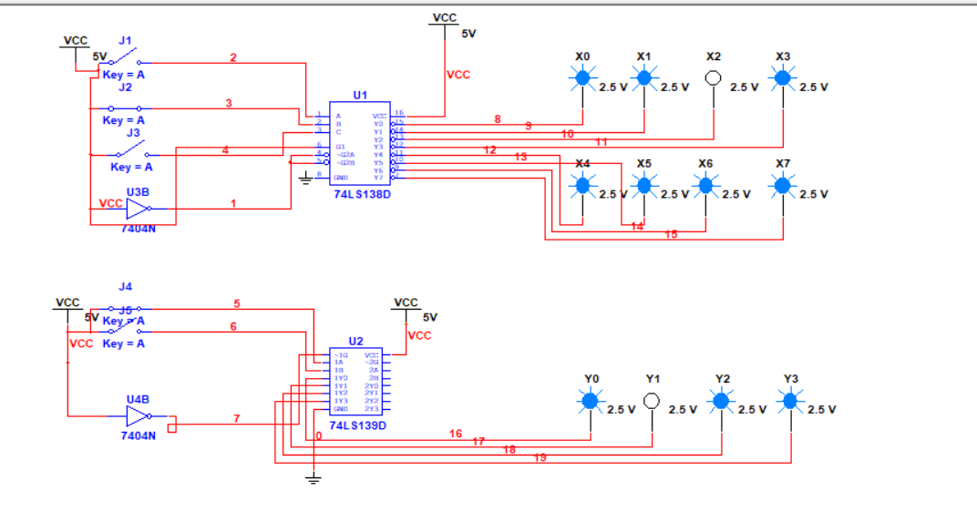

五、思考题

用八根地址线（A7、A6、A5、A4、A3、A2、A1、A0），试用 74LS138 及门电路设计一个地址译码电路，当输入地址为 30H 时， 输出 Y0 为 0，当输入地址为 31H 时，输出 Y1 为 0。

思路：只需要区分开后四位（0000 0001）的不同即可（前面的3=0011都是一样的） 实际上用一个2-4译码器即可.

